**Exercise: Playbooks - Conditionals**

1. Verify that your ansible installation is available by displaying the version of ansible while logged in as the 'user' user.

[test@tcox3 ~]$ ansible --version

ansible 1.9.2

  configured module search path = None

2. Run the ansible command that lists all of the hosts configured in your control server 'hosts' file for the system.

[test@tcox3 ~]$ ansible all --list-hosts

    tcox5.mylabserver.com

    localhost

    tcox4.mylabserver.com

3. Create a playbook, using the 'WHEN' concepts from the video:

- Uses SSH

- Logs in to the remote system as 'test' user

- Connects to one server or group from Step #2 above

- The playbook runs as 'sudo'

- Gathers remote facts

- Installs the 'Apache Web Server' using the appropriate package module

- Each section will determine WHICH Apache package to install based on the value of the fact called 'ansible_os_family' and using the appropriate module for package management

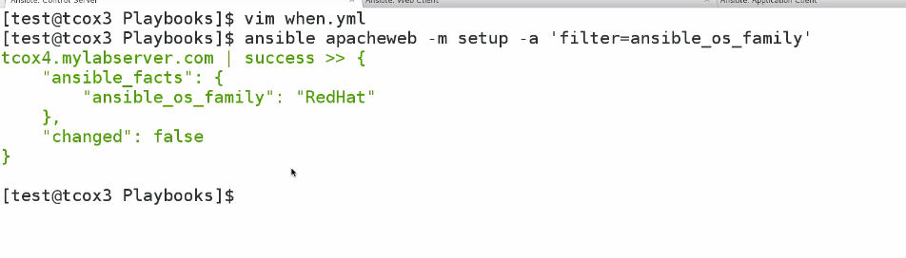

[test@tcox3 Playbooks]$ vim when.yml   
[test@tcox3 Playbooks]$ cat when.yml   
--- # WHEN Playbook Example  
- hosts: aptserver  
  user: test  
  sudo: yes  
  connection: ssh  
  vars:  
    playbook_type: conditionalexample  
  vars_files:  
    - conf/copyright.yml  
    - conf/webdefaults.yml  
  tasks:  
    - name: Install Apache Appropriate to the Distribution Type (Debian/Ubuntu)  
      command: apt-get -y install apache2  
      when: ansible_os_family == "Debian"  
    - name: Install Apache Appropriate to the Distribution Type (RedHat/CentOS)  
      command: yum -y install httpd  
      when: ansible_os_family == "RedHat"

4. Run the playbook and display the results.

[test@tcox3 Playbooks]$ ansible-playbook when.yml   
  
PLAY [aptserver] **************************************************************   
  
GATHERING FACTS ***************************************************************   
ok: [tcox1.mylabserver.com]  
  
TASK: [Install Apache Appropriate to the Distribution Type (Debian/Ubuntu)] ***   
changed: [tcox1.mylabserver.com]  
  
TASK: [Install Apache Appropriate to the Distribution Type (RedHat/CentOS)] ***   
skipping: [tcox1.mylabserver.com]  
  
PLAY RECAP ********************************************************************   
tcox1.mylabserver.com      : ok=2    changed=1    unreachable=0    failed=0

